APRIL 7th 2021 REGULAR MEETING OF THE BOARD OF TRUSTEES

CALL TO ORDER
Mayor Harter will call the meeting to order with the Pledge to the Flag at 7:30 p.m.
Board Members Present: Mayor Harter, Trustee Fuller, Trustee Olejniczak, Trustee Werner Jahrling, Trustee Roach
Board Members Absent: None
Also, Present: Attorney Cassidy (Zoom), Treasurer Geller, Clerk Wierzbicki
Approximate Number in Audience: none

II. MINUTES
Motion made by Trustee Fuller seconded by Trustee Olejniczak to approve the minutes of the March 3, 2021 Regular meeting

VOTE: YES 5 NO 0

Motion made by Trustee Fuller seconded by Trustee Olejniczak to approve the minutes of the March 19, 2021 Special meeting.

VOTE: YES 5 NO 0

Motion made by Trustee Fuller seconded by Trustee Jahrling to approve the minutes of the March 29, 2021 Special meeting.

VOTE: YES 5 NO 0

Motion made by Trustee Fuller seconded by Trustee Fuller to approve the minutes of the April 5, 2021 Organizational meeting.

VOTE: YES 5 NO 0

III. FINANCIAL REPORTS

- Treasurer’s Report
Motion made by Trustee Olejniczak seconded by Trustee Jahrling to accept the March Treasurer’s report as submitted.
VOTE: YES 5 NO 0
2. Payment of Vouchers
Motion made by Trustee Fuller seconded by Trustee Roach to approve payment of the vouchers as audited.
VOTE: YES 5 NO 0

- Transfers 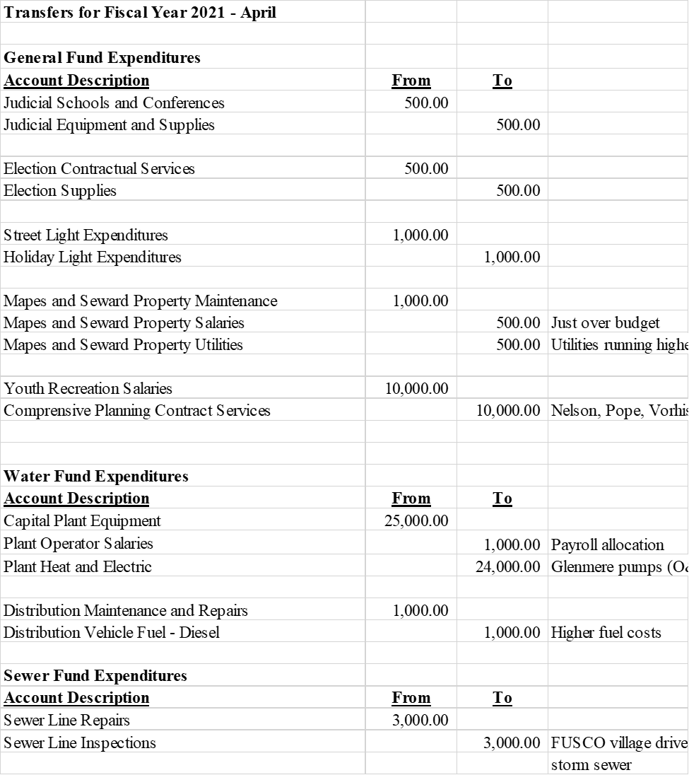
Motion made by Trustee Jahrling seconded by Trustee Fuller to approve the transfers as presented.
VOTE: YES 5 NO 0

IV. ANNOUNCEMENTS, CORRESPONDENCE & PRESENTATIONS
- Altice sent a letter regarding programming changes with MGM Network.
- Representative Karl Brabenec sent a letter to NYSDOT regarding condition of the roads on Route 94 in the Village.
- CLG Insurance sent a notice regarding COVID-19 vaccines for NYS employees.
- Comp Alliance sent a plan summary for the Village on 3/8/2021.
- Esposito & Associates sent a letter to Robert Scott regarding Village Drive Commons.
- Fusco Engineering sent a letter about the purchasing of the paper streets.
- Fusco Engineering sent a letter regarding the bid and a draft design.
- Gregory Moyer Fund sent a proposal for new AED’s.
- Phillip Hamling sent a letter regarding the water lines at 126 North Main Street.
- JET Environmental Testing sent a letter about the pre-demolition asbestos survey.
- J.M Electric sent a proposal for electrical work to be done at the Werner Ave Pump Station.
- Kuperus Fencing sent a proposal for a new fence at the sewer plant.
- Limnology Information and Freshwater Ecology sent a letter regarding Glenmere Lake.
- Tom Mance sent an estimate for the sewer plant roof.
- NYSDOT sent an updated CHIPS reimbursement for 2020-2021.
- Orange County Commissioner of Finance sent a notice of return of taxes for 2020-2021.
- Orange County Commissioner of Finance sent a statement about Village Taxes in 2018-2019.
- Orange County Department of Planning sent a memo regarding municipal permits.
- Peckham Road Corp sent an estimate of $62,360.00 for chips.
- Roe Brothers sent a quote for the polycarb panel at the sewer plant.
- The State Senator Mike Martucci sent a letter in regards to grants.
- John & Margaret Sgombick sent a letter regarding the purchasing of the paper streets.
- Travelers Insurance sent a notice regarding the expiration of insurance.
- U.S Specialty Insurance Company sent a notice of the policy change.
- Mike Pawliczek Code Enforcement Officer sent a letter regarding the unsafe conditions located at the property at 93 Randall Street.
- J & L Werner Realty LTD sent a letter with regards to the garbage pickup at 8-10 North Main Street.

V. REPORTS OF THE TRUSTEES

1. Thomas Fuller – Police, Justice, Emergency Management
2. Craig Olejniczak – Parks, Recreation, Buildings Grounds, Animal Control
3. Alyssa Jahrling – DPW, Sewer/Water, Chamber of Commerce
4. Matthew Roach – Building & Planning, Zoning and Historical,

VI. PUBLIC COMMENT – AGENDA ITEMS ONLY

This opportunity is provided for members of the audience to comment on any item listed on the agenda. Please address the Board and limit your comments to five minutes.

All comments were made via Zoom were not on Agenda

VII. UNFINISHED BUSINESS

- AED Proposal

Motion by Trustee Jahrling second by Trustee Olejniczak the purchase of 5 G5plus AEDs in the amount of $ 1395.00 from Gregory Moyer Fund.
VOTE: YES 5 NO 0

- DPW Bin Proposal

Motion by second by the purchase of new trash and recycling bins for each resident to use with new truck in the amount of $125,615.00 on state bid from Sanitation Equipment.

Motion to table by Trustee Fuller seconded by Trustee Olejniczak
VOTE: YES 5 NO 0

VIII. NEW BUSINESS

- Village Engineer
Motion to approve H2M Village of Florida on call General Engineers for the 2021-2022 FY
Motion by Trustee Fuller seconded by Trustee Roach
VOTE: YES 5 NO 0

- Demolition Permit Approval 93 Randall

Chapter 47 of Village Code within 45 days remove or made safe.
Motion to authorize Attorney Cassidy to send notice pursuant to Chapter 47 regarding unsafe conditions and the need of demolition of property. Motion by Trustee Fuller Seconded by Trustee Olejniczak
VOTE: YES 5 NO 0

IX. Meeting Schedule
April 14, 2021 7:00 Budget Meeting Public Hearing
May 5, 2021 9:30 AM Work Session/7:30PM General Meeting
May 19, 2021 9:30 AM Work Session
May 26, 2021 7:00 PM End of Year
June 2rd, 2021 9:30AM Work Session/ 7:30 PM General Meeting

- PUBLIC COMMENT

Jim Piscatelli asked the plan on the chickens.
Trustee Olejniczak stated that Code Enforcement handles
Mayor Harter states that no chickens are allowed in Village and it is being addressed. These laws have been in place for years. People who have the birds will be notified and will have a certain amount of time to comply. Chapter 119 Village code
John Mascis requested when Stop Sign will be placed on Highland
Mayor Harter stated that the speed sign was placed there and has definitely made a difference and we will continue to assess.
Theresa Conlon-Now that the easement has been fixed & the area paved, there is still rock and debris in that area on Village Drive. There is also debris & rocks within Center Circle where the materials were stored. There is also curb damage from the trucks.
Mayor Harter- A lot of questions to address, I am not sure if Village Park is on the Agenda to be tar and chipped this year. We have an IMA agreement with Goshen to possibly have them sweep through. Curb damage I am not familiar with.

Mayor Harter: Jayne Street bridge the gears of Government grind slowly, Warwick requested a grant for repair. I appreciate everyone’s patience on this project.

John Mascis How many times were the AED units used in 17 years

Trustee Fuller In the police cars they were used.

- ADJOURNMENT

Motion made by Trustee Jahrling seconded by Trustee Olejniczak to adjourn the meeting at 8:30 PM.
VOTE: YES 5 NO 0

